**ExNo.1** **Date:**06.12.17

Creating tables and insert five records (Customer Details).

**Syntax:**

Create Table <table name>( Column_Name Data_type(Size));

**Output:**













**Describe Table:**

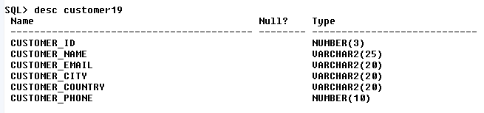

**View Table:-**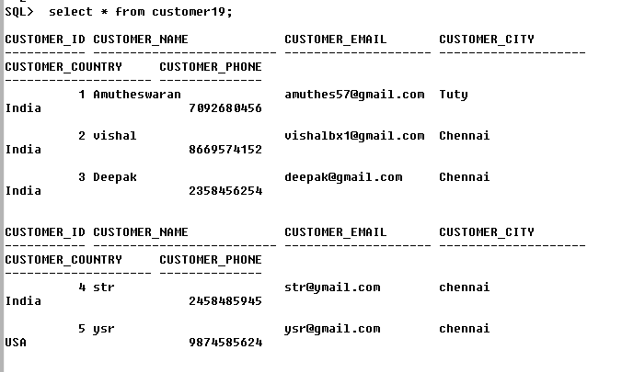

**ExNo.2** **Date:**07.12.17

Creating tables and insert five records (Employee Details).

**Syntax:**

Create Table <table name>( Column_Name Data_type(Size));

**Output:**



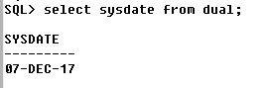

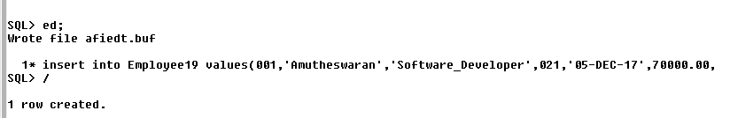



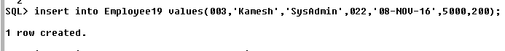

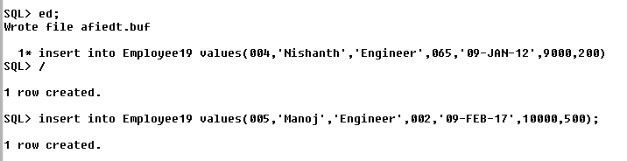

**Describe Table:**

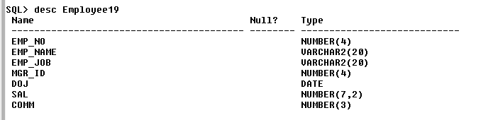

**View Table:**

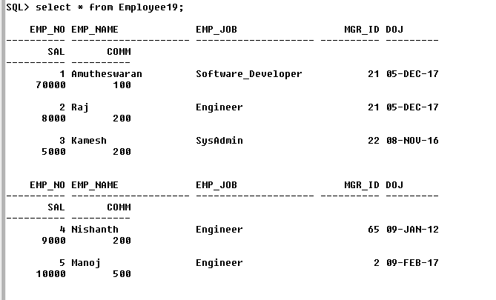

**ExNo.**3 **Date:**13.12.17

Changing the data type for of the single column.

**Syntax:**

Alter table <table name> modify <column name> <new data type(size)>

**Output:**



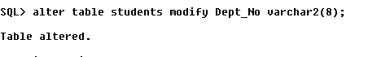

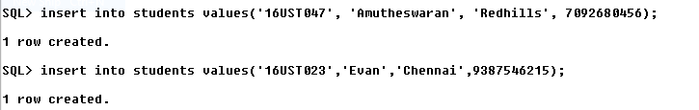

**Describe Table:**

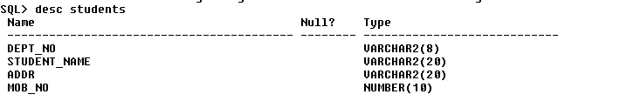

**View Table:**

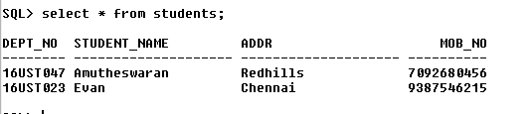

**ExNo.**4 **Date:**13.12.17

Changing the data type for of the multiple column.

**Syntax:**

altertable <table name> modify (column name1 new datatype(size) , column name2 new data type(size)…………….. )

**Output**

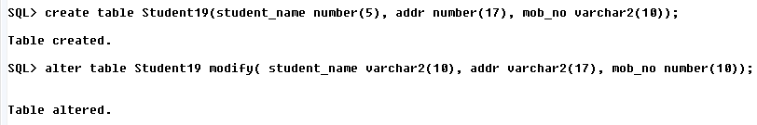

**ExNo.**5 **Date:**13.12.17

Adding column to the table for a single column

**Syntax:**

alter table students add GRADE varchar2(1);

desc students;

**Output:**



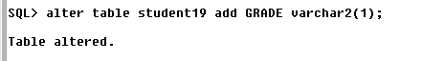

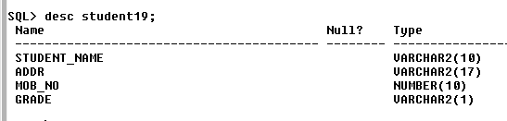

**Ex No.**6 **Date:**14.12.17

**For multiple column**

In student table to add column by name DOB date, SEX varchar2(1), Last_Name varchar2(20);

**SYNTAX:**

Alter table <table name> ADD (column name_1 data type (size), column name_2 data type(size)……)

Alter table students add (DOB date, SEX varchar2(1), Last_name varchar2(20));

Desc students;

**OUTPUT:**





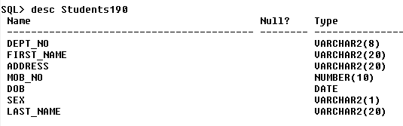

**ExNo.**7 **Date:**14.12.17

Dropping / removing a column(s) from the table for single column

**SYNTAX:**

In student table, to drop a column Last_Name

Alter table <students> drop column <column name>

Alter table students drop column Last_Name;

Desc students

**OUTPUT**



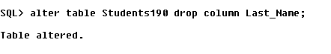

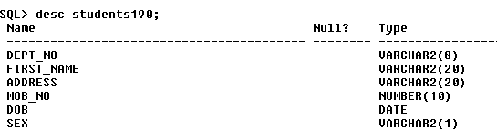

**ExNo.**8 **Date:**14.12.17

For multiple column

In students table, to drop a column DOB, SEX

**SYNTAX:**

Alter table <table name> drop ( Column name1, column name2….)

Alter table drop (DOB, SEX);

**OUTPUT:**

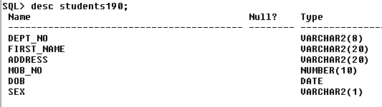

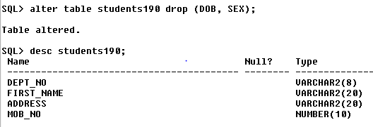

**ExNo.**9 **Date:**14.12.17

Dropping the table.

**SYNTAX**

Drop table <table name>

Drop table students;

Desc students;

**OUTPUT:**

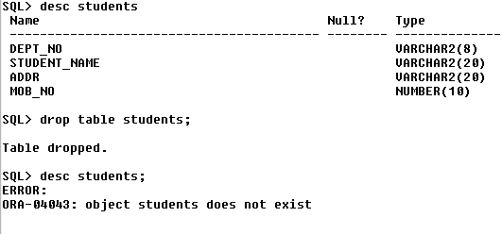

**ExNo.**10 **Date:**18.12.17

**Primary Key Constraint**

Create table <table name> ( Emp_No number(4) primary key, Emp_Name varchar2(20), Salary number(5), Dept_No number(2));









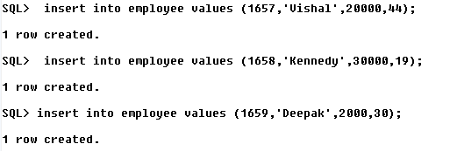

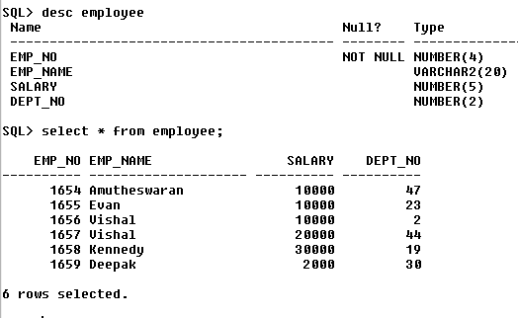

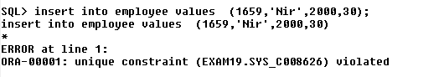

**Ex.No:**11 **Date:**20-12-17

Foreign Key Or Reference Key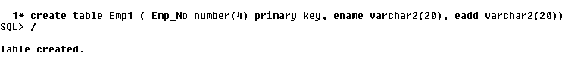



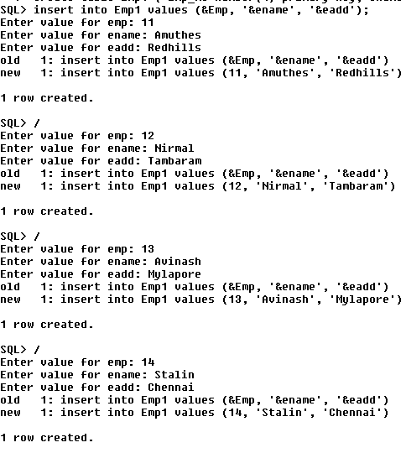

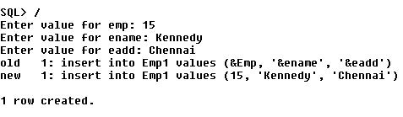

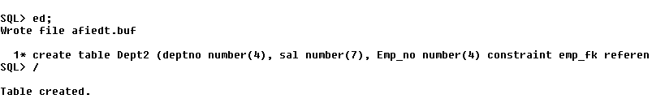

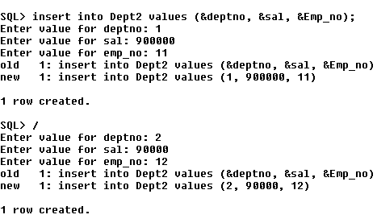

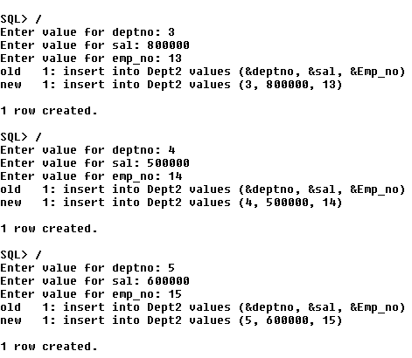

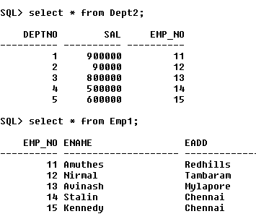

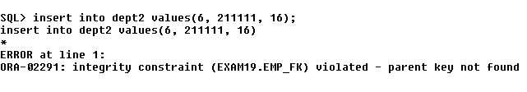

**Ex.No:**11B  **Date:**19-01-18

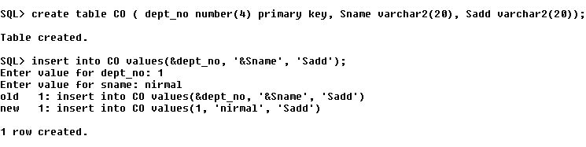

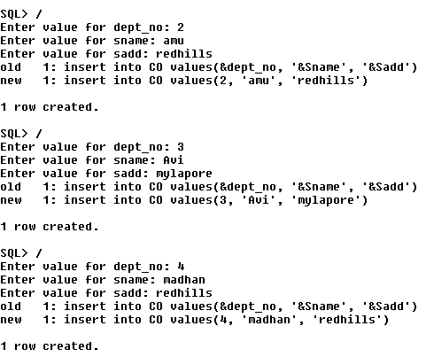

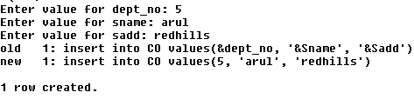



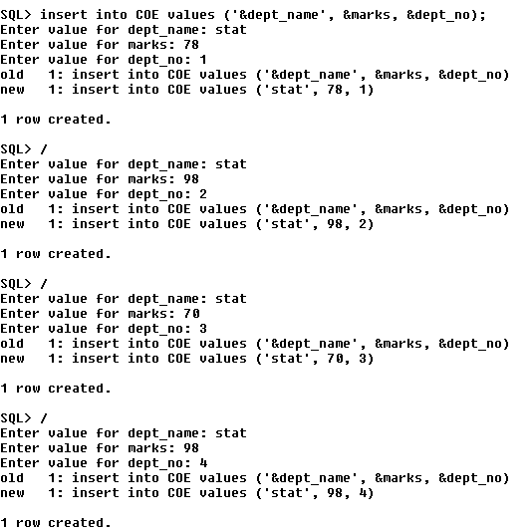

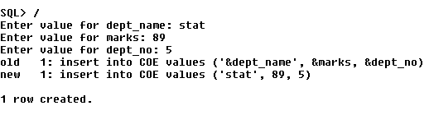

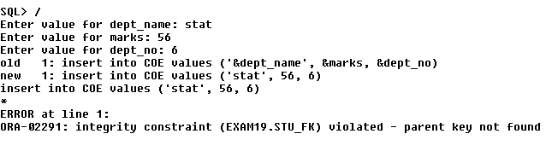

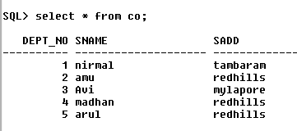

**Ex.No:**11C **Date:**22-01-18

Check Constraint

Create table emp (empno number(4) , ename varchar2(20), sal number(7), constraint emp_ck

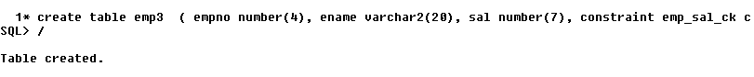

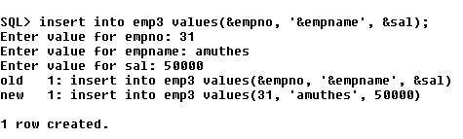

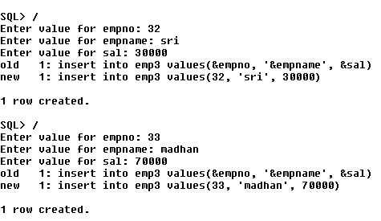

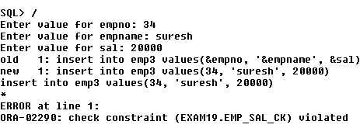

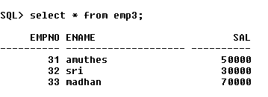

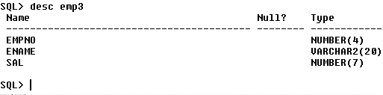

**Ex.No:**11D **Date:**25-01-18

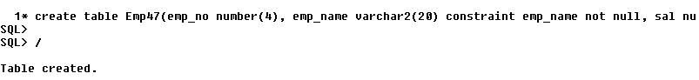

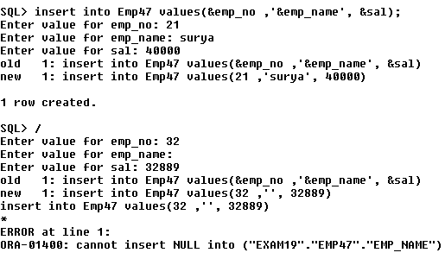

**Ex.No:**12 **Date:**19-01-18

View the constraints

Select * from user_constraints;

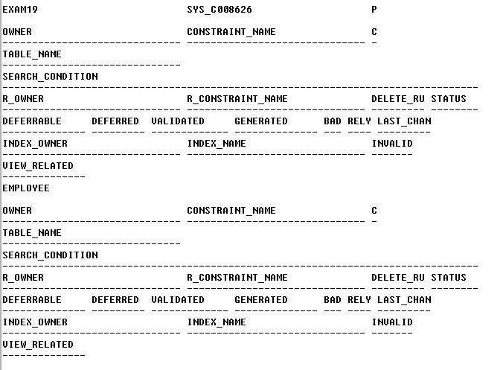

**Ex.No:**13 **Date:**19-01-18

Renaming The Table

**Syntax:**

Rename old table name to new table name

**Output:**

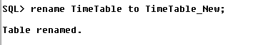



**Ex.No:**14 **Date:**19-01-18

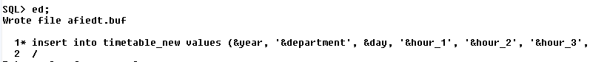

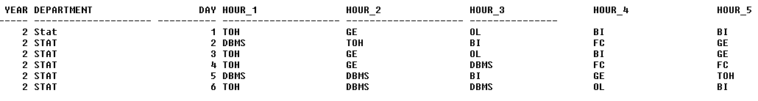

**Ex.No:**15 **Date:**29-01-18



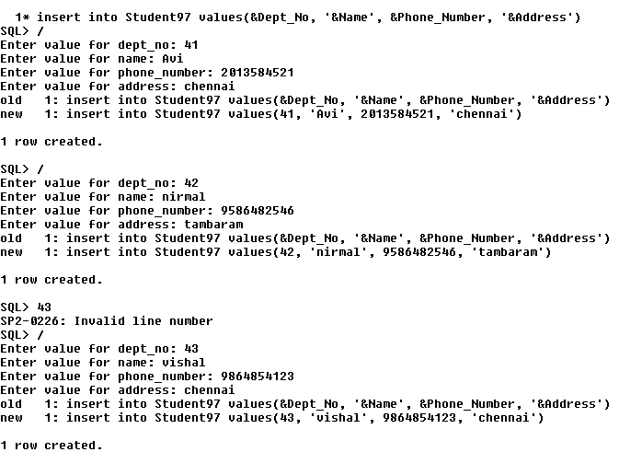

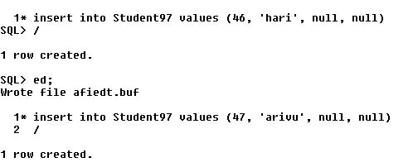

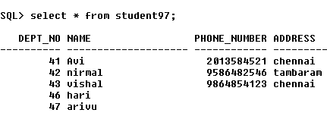

**Ex.No:**16 **Date**:29-01-18

Transaction Control Language



**Ex.No:**17 **Date:**29-01-18

Deleting A Row(s)

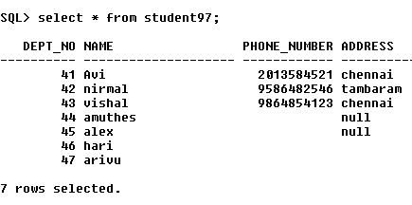

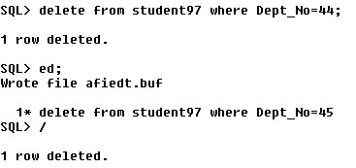

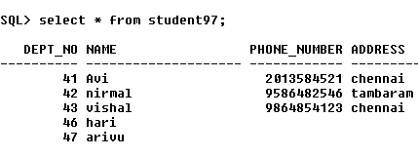

**Ex.No:**18  **Date:**29-01-18

Inserting the values only few fields



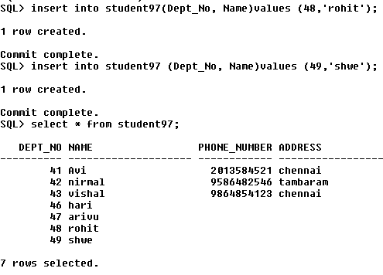

**Ex.No:**19 **Date:**29-01-18

Updating Single columns

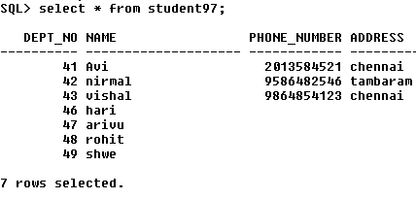



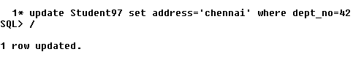 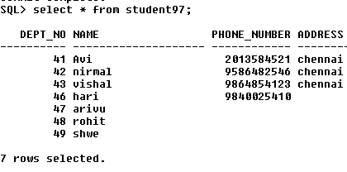

**Ex.No:**20 **Date:**29-01-18

Updating Multiple columns

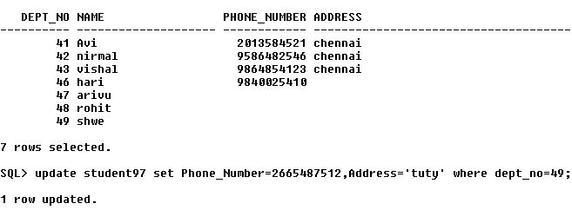

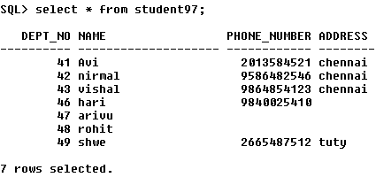

**Ex.No:**21 **Date:**30-01-18

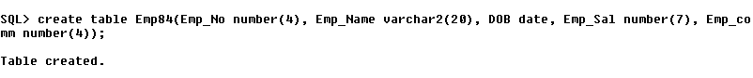

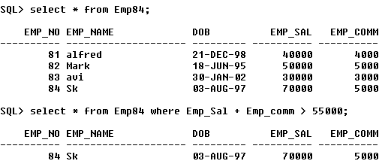

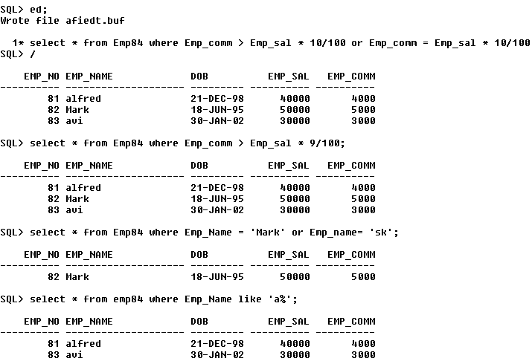

**Ex.No:**22 **Date:**30-01-18

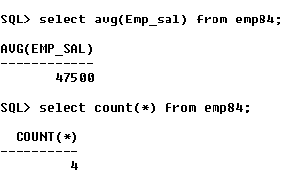

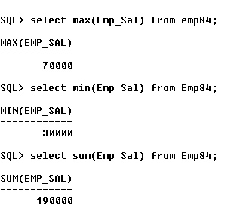

**Ex.No:**23 **Date:**30-01-18

Inbuilt Function:-

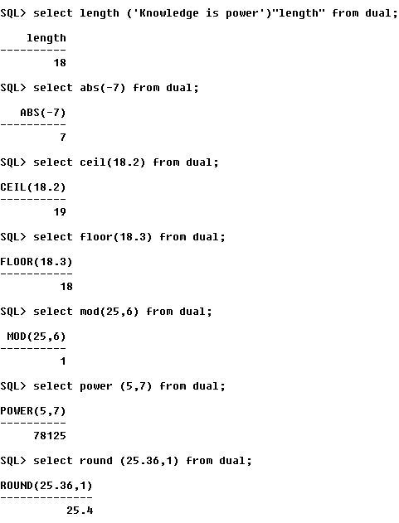

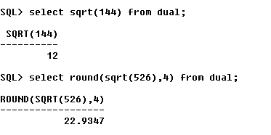

**1st  CIA Answers**

**Ex.No:**24 **Date:**08-02-18

**1)Create Table for the following structure**



**Ex.No:**25 **Date:**08-02-18

**2) Create Table For The Following Columns**



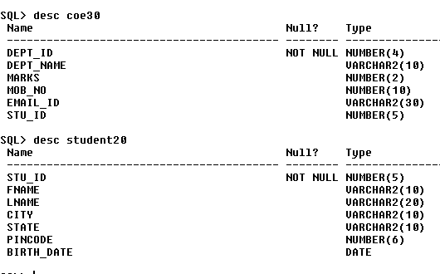

**Ex.No:**26 **Date:**08-02-18

**3) a)insert 3 records in both the tables**

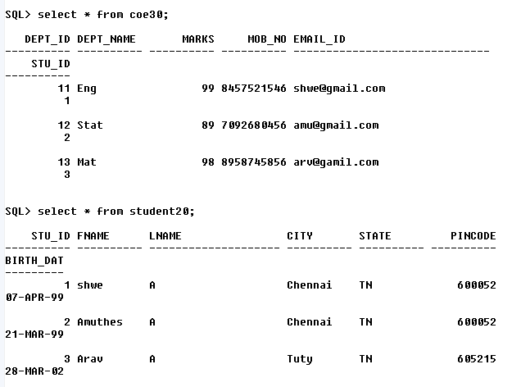

**b)update any one record (State)**

**c)Modify anyone of the column’s datatype size**

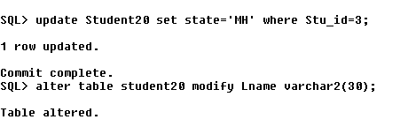

**d) Add a column aadhar_no to anyone of the above table**

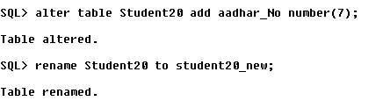

**e) Rename The table name student to student_new**

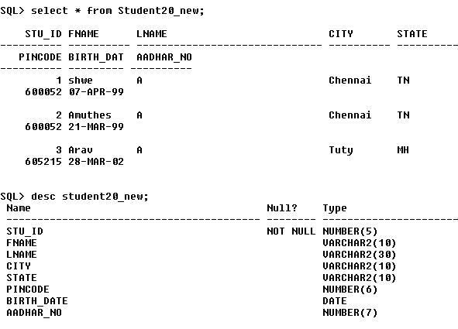

**Ex.No:**27 **Date:**08-02-18

**4) Create table and insert records for the following information**



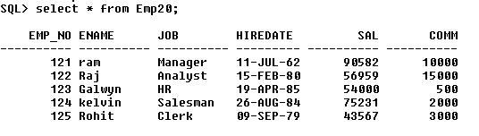

**Ex.No:**28 **Date:**08-02-18

**5)Consider The EMP Tables**

a)Select employee(s) Whose salary+commission is more than 5500

b)Select employee(s) details whose commission is more than 15% of their salary

c)Select the employee(s) whose job is either HR or ANALYST

d)Select the employee(s) whose name starts with ‘R’ followed by any number of characters

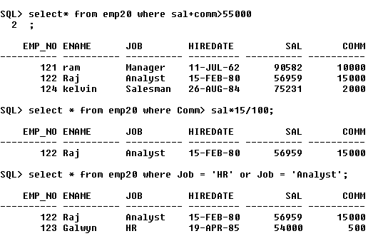

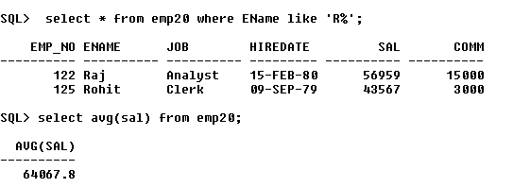

**Ex.No:**29 **Date:**08-02-18

**6)**

1. **Illustrate the following built in function in SQL based on the EMP table**

**a)AVG**

**b)COUNT**

**c)MAX and MIN**

**d)SUM**

**(ii) Illustrate the following built in function in SQL**

**a)Length**

**b)Abs**

**c)Ceil**

**d)Floor**

**e)Sqrt**

**f)Mod**

**g)Power**

**h)Round**

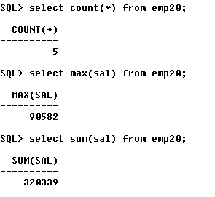

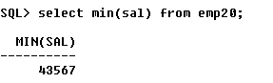

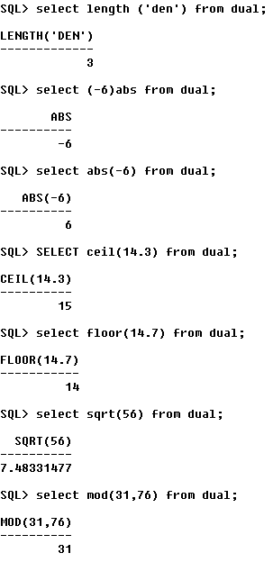

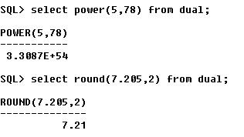

**Ex.No:**30 **Date:**16-02-18

**Logical Operator:**

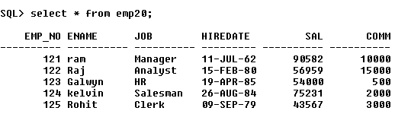

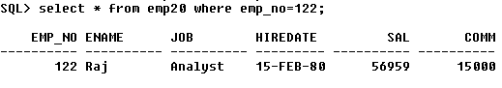

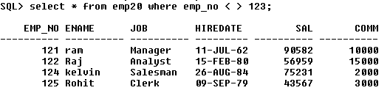

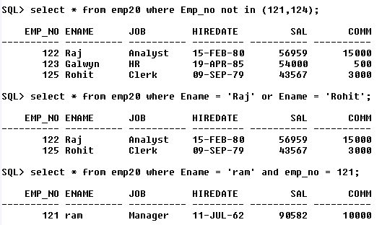

**Ex.No:**31 **Date:**19-02-18

**Relational Operator**

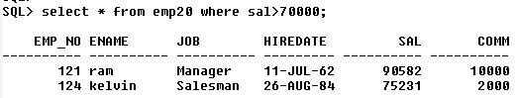

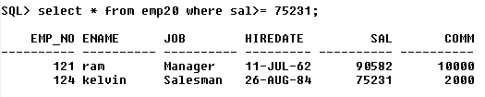

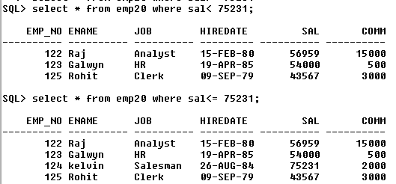

**Ex.No:**32 **Date:**19-02-18

String Operator:-

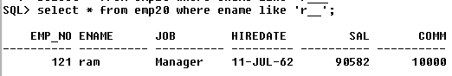

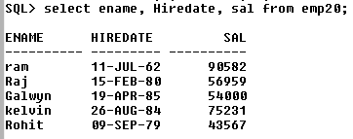

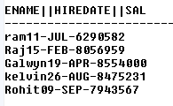

**Ex.No:**33 **Date:**20-02-18

**Character Function**

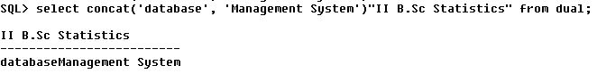

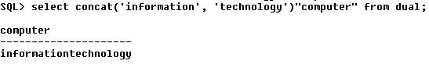

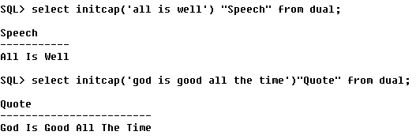

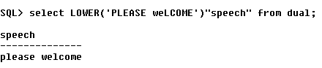

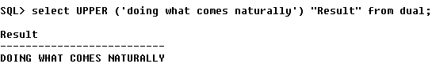

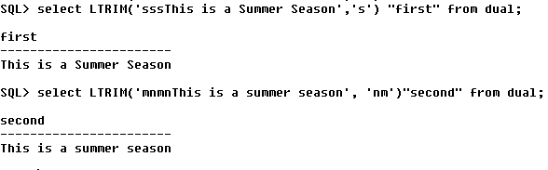

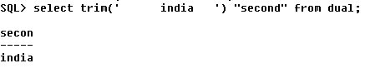

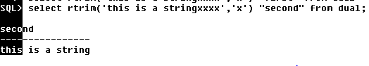

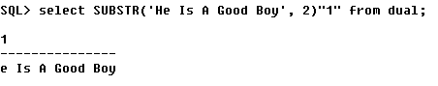

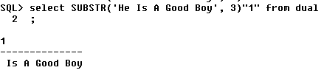

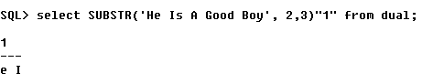

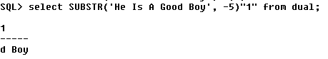

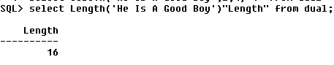

**Ex.No:**34 **Date:**20-02-18

**Numeric Function**

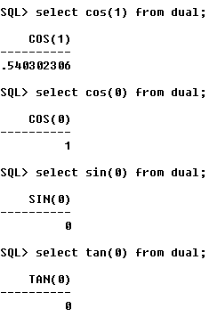

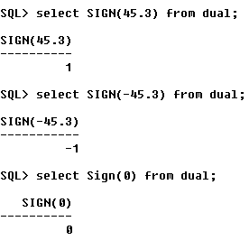

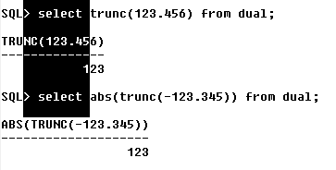

**Ex.No:**35 **Date:**23-02-18

Data Function

a)

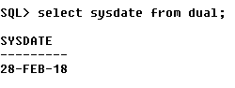 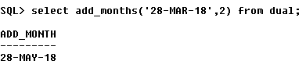

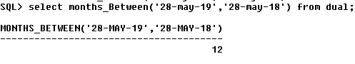

b)

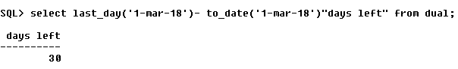

select last_day('1-mar-18')"current", last_day('1-mar-18') - to_date('1-mar-18')"days left" from dual;

c)

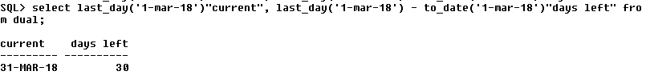

d)

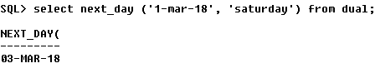

e) & f) & g)

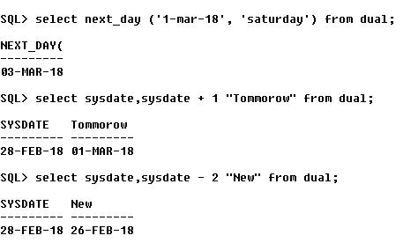

h)

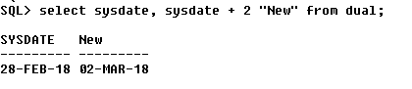

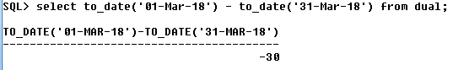



**Ex.No:**36 **Date:**01-03-18

Convension Function

a)

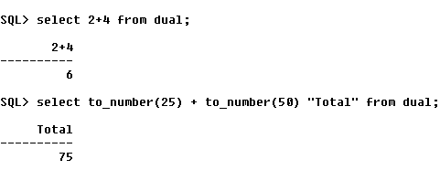

b)

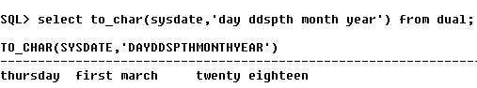

c)

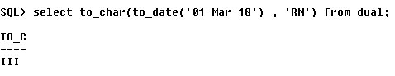

d)

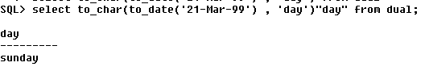

e)

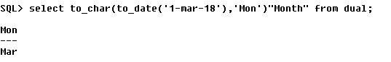

f)

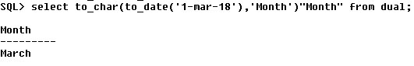

g)

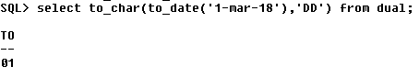

h)

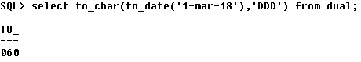

i)

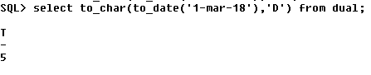

j)

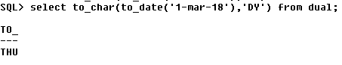

k)

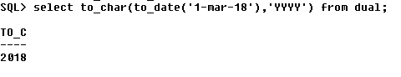

l)

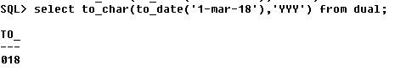

m)

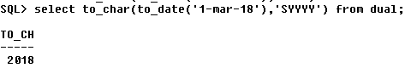

n)

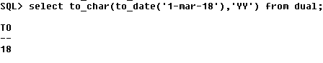

o)

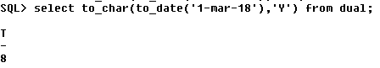

p)

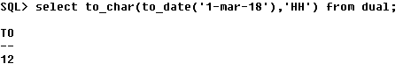

q)

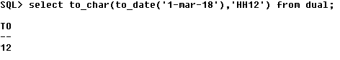

r)

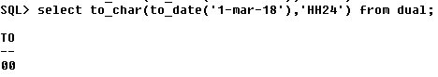

s)

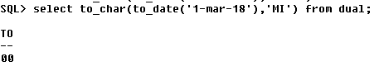

t)

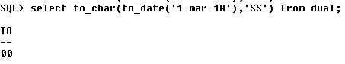

u)

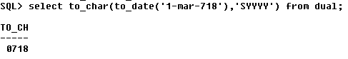



**Ex.No:**37 **Date:**05-03-18

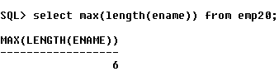

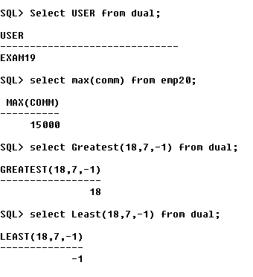

**Ex.No:**38 **Date:**05-03-18

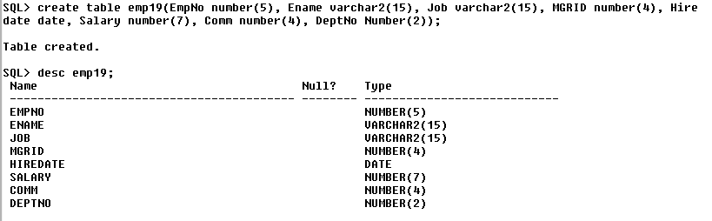

**SELECT ONE OR MORE COLUMN FROM THE TABLE:**

**a)**

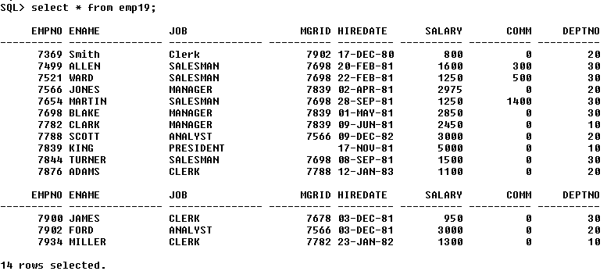

b)

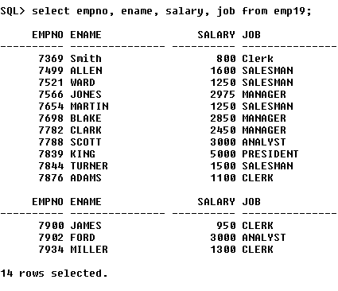

c)

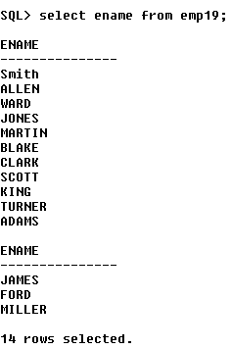

**CHANGING THE COLUMN NAME USING ALIASES:**

d)

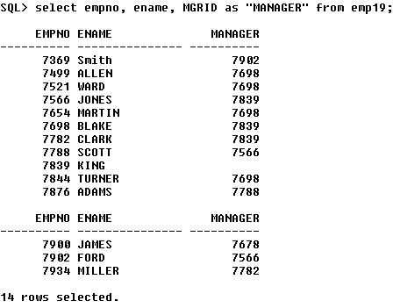

e)

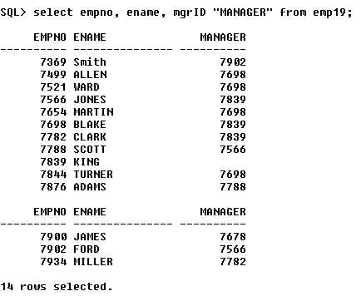

**USING WHERE CLAUSE:**

f)

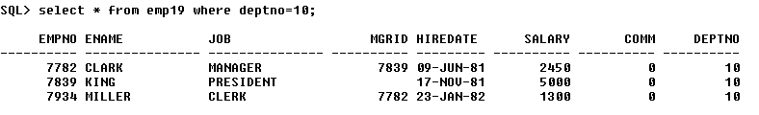

g)

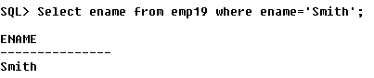

h)

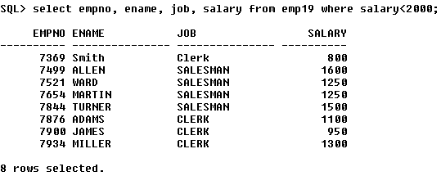

i)

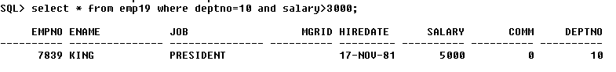

j)

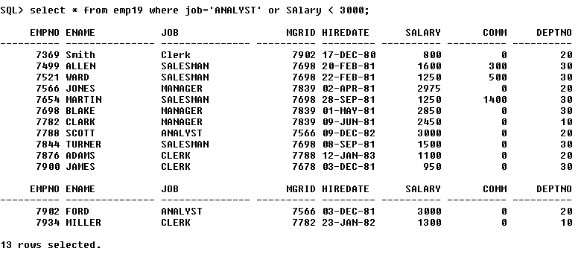

k)

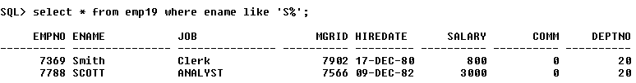

l)

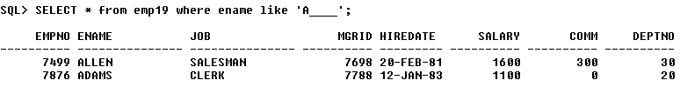

m)

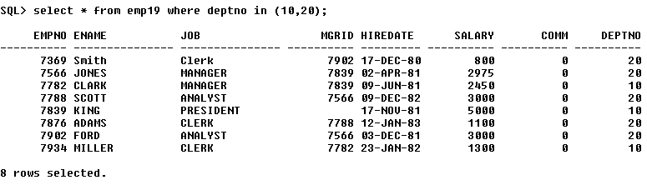

n)

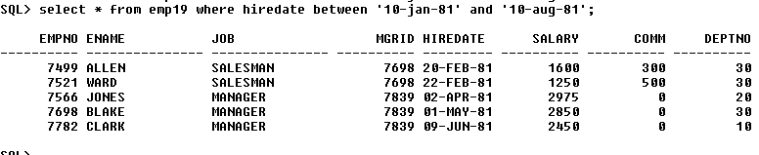

**Ex.No:**39 **Date:**08-03-18

**Working With Null Values**

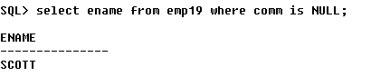

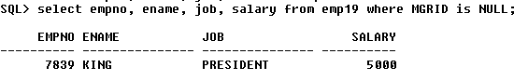

**Ex.No:**40 **Date:**08-03-18

Order by Clause

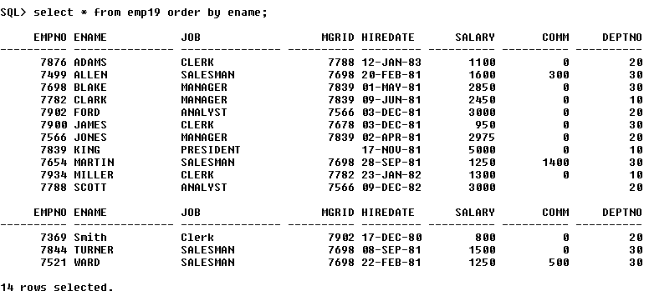

**Ex.No:**41 **Date:**08-03-18

Group By Clause

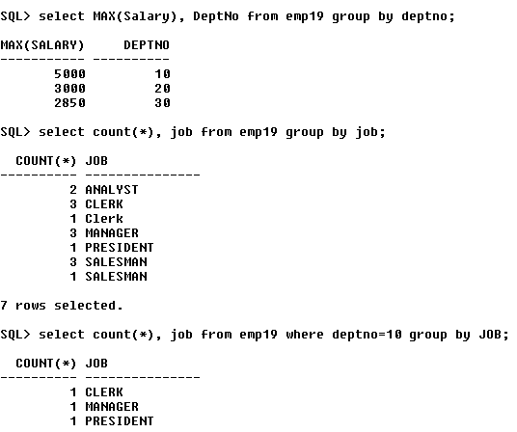

**Ex.No:**42 **Date:**08-03-18

Group by Having Clause

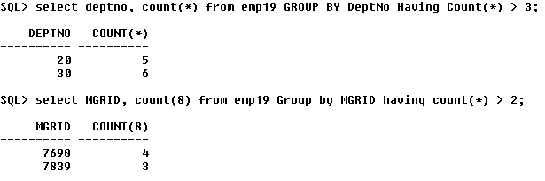

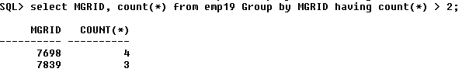

**Ex.No:**43 **Date:**08-03-18

**Sub query**

Select empno, ename, job, deptno from emp19 where deptno = ( select deptno from dept where dname = ‘sales’);

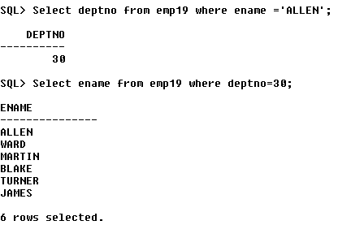

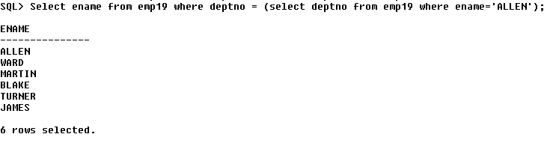

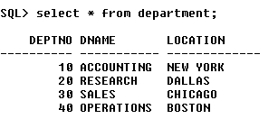  
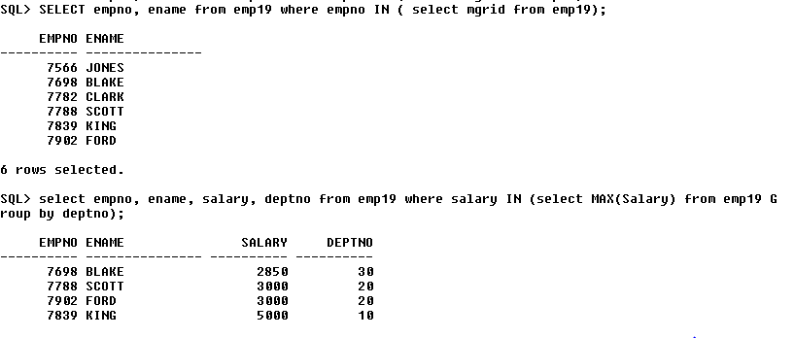

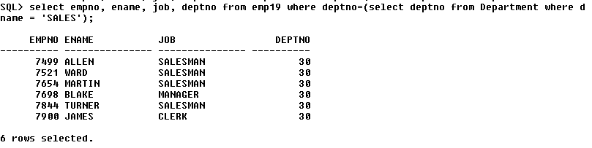

**Ex.No:**44 **Date:**16-03-18

**Correlated Sub-Query:**

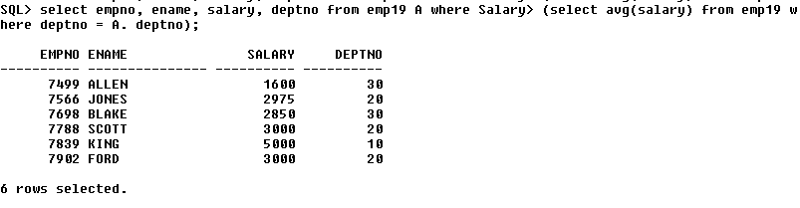

**Ex.No:**45 **Date:**16-03-18

1. Cartesian Join

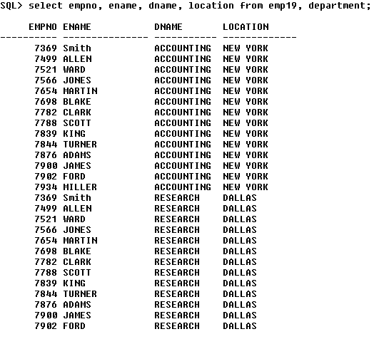

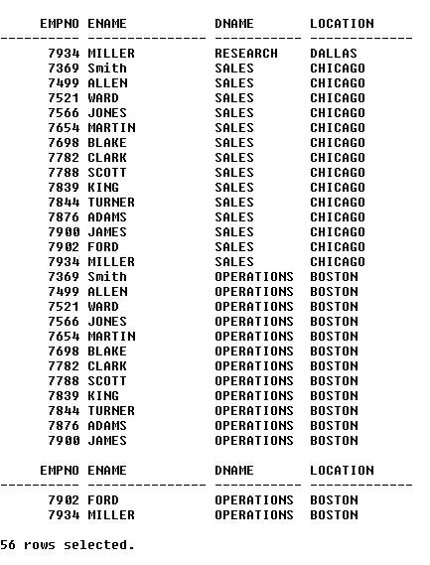

1. Equi Join

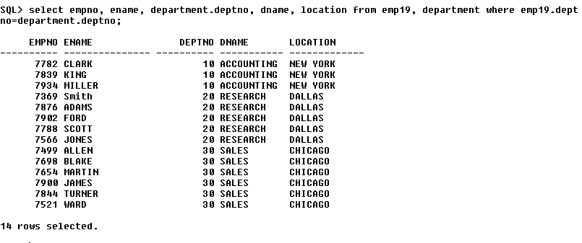

1. Using table aliases

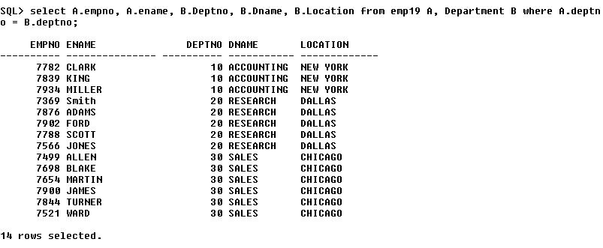

d)

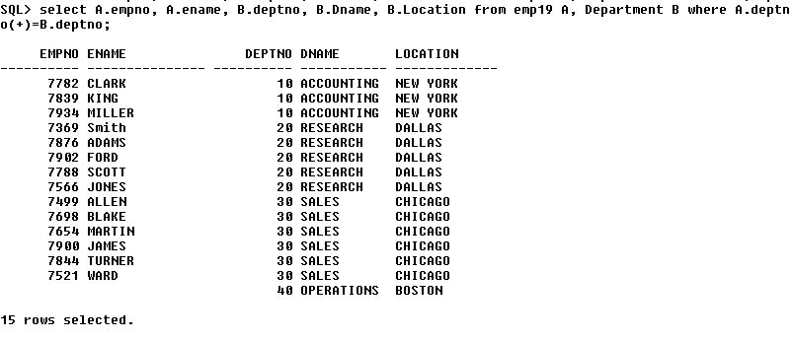

**Ex.No:**46 **Date:**20-03-18

1. Creating View:



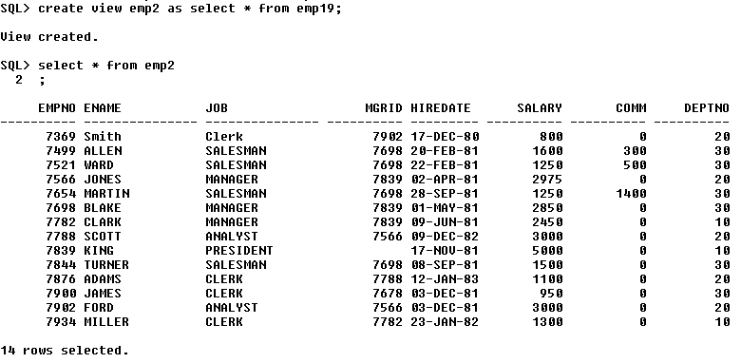

b)

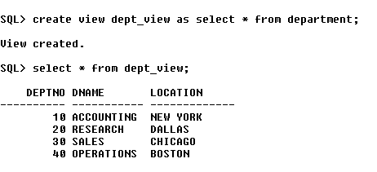

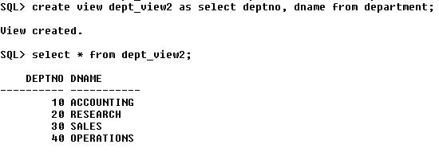

c) check option clause



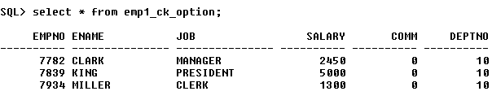

d)Force view

